Link youtube :
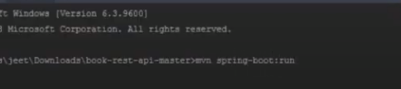

Tạo thư mục webapp -> run npx create-react-app reactjs
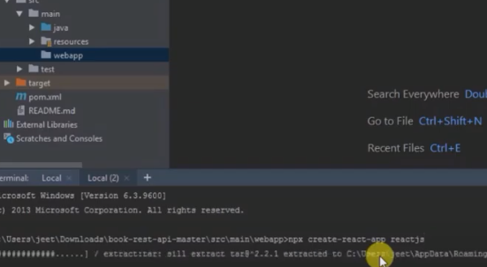

Cài bootstrap react
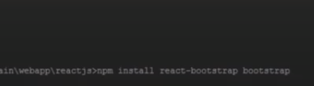

3 - React And Spring Boot : How to set up Router and Route?

Cách căn chỉnh CSS trong ReactJS (Utilities): https://coreui.io/docs/utilities/text/#text-alignment
Cài đặt react-router-dom: npm install --save react-router-dom

4 - How to create & submit form in React?
Có 2 cách viết extend từ class
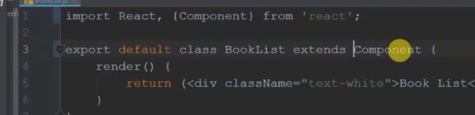
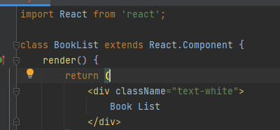

Tìm hiểu về bind() trong Class Component?
https://viblo.asia/p/su-dung-bind-cho-cac-ham-cua-class-components-trong-react-lieu-co-can-thiet-OeVKBDPylkW
Cài đặt font-awesome: https://github.com/FortAwesome/react-native-fontawesome
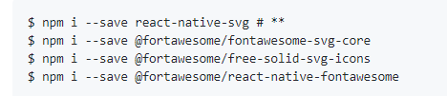

Nên sử dụng Fetch hay Axios ?
https://anonystick.com/blog-developer/axios-vs-fetch-2020-nen-su-dung-thang-nao-voi-nhung-tinh-nang-moi-trong-javascript-2020010754182944
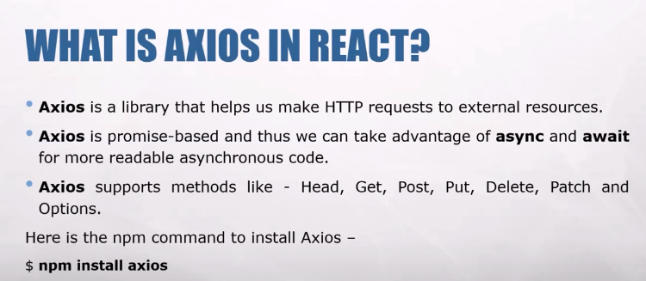
Cài đặt axios: npm install axios

